# **1. Modul Alumni Pelajar**

## 1.1 Introduction

|  |  |
| --- | --- |
| User role | Staff and Student |
| Backend/frontend | Both |
| Brief Description | Manage student alumni, kaji selidik kebolehpasaran lepasan pelajar IKBN/IKTBN and fill up questionnaire (student) |

## 1.2 Schema

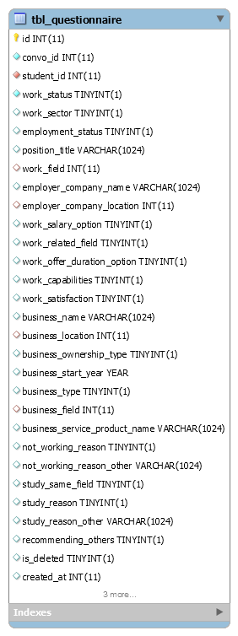

Figure 3.1 Schema Modul Alumni Pelajar

## 1.3 Coding

### 1.3.1 Controllers

1. **\backend\modules\alumni\controllers\MarketabilityController.php**

|  |  |
| --- | --- |
| **Class/Function** | **Description** |
| actionIndex | action to display page Kajian Kebolehpasaran Lepasan Pelajar |

2. **\backend\modules\alumni\controllers\QuestionnaireController.php**

|  |  |
| --- | --- |
| **Class/Function** | **Description** |
| actionIndex | action to list student’s questionnaire |
| actionView | action to view selected questionnaire |

3. **\backend\modules\alumni\controllers\ReportController.php**

|  |  |
| --- | --- |
| **Class/Function** | **Description** |
| actionWorking | action to list senarai bekerja |
| actionBusiness | action to list senarai berniaga |
| actionNotWorking | action to list senarai tidak bekerja |

4. **\frontend\modules\alumni \controllers\QuestionnaireController.php**

|  |  |
| --- | --- |
| **Class/Function** | **Description** |
| actionIndex | action to list questionnaire |
| actionCreate | action to create questionnaire data |
| actionUpdate | action to update questionnaire data |

### 1.3.2 Models

**1. \backend\modules\alumni\models\Questionnaire.php**

|  |  |
| --- | --- |
| **Class/Function** | **Description** |
| getBusinessField | Join Field model (one-to-one) |
| getWorkField | Join Field model (one-to-one) |
| getBusinessLocation | Join State model (one-to-one) |
| getEmployerCompanyLocation | Join State model (one-to-one) |
| getStudent | Join Student model (one-to-one) |
| getConvoCourse | Join ConvoCourse model (one-to-one) |

### 1.3.3 Search Models

**1. \backend\modules\alumni\models\QuestionnaireSearch.php**

|  |  |
| --- | --- |
| **Class/Function** | **Description** |
| Search | Filter Questionnaire model with condition and join with Student model |

### 1.3.4 Views

**1. \backend\modules\alumni\views\marketability**

|  |  |
| --- | --- |
| **File Name** | **Description** |
| index.php | Display index page for Kebolehpasaran Lepasan Pelajar |

**2. \backend\modules\alumni\views\questionnaire**

|  |  |
| --- | --- |
| **File Name** | **Description** |
| index.php | Display index page for questionnaire |
| student-details.php | Display student’s details page |
| view.php | View questionnaire data in detail |

**3. \backend\modules\alumni\views\report**

|  |  |
| --- | --- |
| **File Name** | **Description** |
| business.php | Display report page for Senarai Berniaga |
| not-working.php | Display report page for Senarai Tidak Bekerja |
| working.php | Display report page for Senarai Bekerja |

**4. \frontend\modules\alumni\views\questionnaire**

|  |  |
| --- | --- |
| **File Name** | **Description** |
| form.php | Create questionnaire data with form |
| _formQuestionnaire.php | Hold questionnaire template |
| update.php | Update questionnaire data with form |
| create.php | Create questionnaire data |
| _index.php | Display index page for questionnaire |